**C:\Documents and Settings\Jessica\Local Settings\Temporary Internet Files\Content.IE5\AMD2Q9TA\MC900232724[1].wmfPreparing for Kindergarten**

The following pages contain information about how to get your child ready for kindergarten, simple activities to help them learn their basics, checklists and guides, and resources for further information.

### **C:\Documents and Settings\Jessica\Local Settings\Temporary Internet Files\Content.IE5\RQF8C881\MC900441754[1].pngSome things that help your child learn are . . .**

### Boardgames

### Books

### Calendars

### Crayons and Markers

### Educational TV Shows (Sesame Street, Dora the Explorer, etc.)

### Flashcards

### Paint

### Playdough

### Playground equipment

### Puzzles

### Songs/ music/ nursery rhymes

### **Reading and Language**

* Read to your child every day.
* Read by yourself to set a good example.
* Give your child many reading materials to explore and writing materials to use.
* Visit the library often, and participate in story times and other activities there.
* Read aloud signs like "No Parking" and "Exit" and talk about what the signs mean.
* Sing songs & say nursery rhymes together.
* Play with alphabet letters, and help your child to identify letter names and words that begin with the sound the letter makes.
* Use new and different words to describe what you see, hear, and feel. Do this to help your child develop language skills.
* Encourage your child to write notes using scribble writing and pretend spelling.
* Turn a shoe box into a mail box and use it to send notes to each other. Take turns reading what you have "written."

|  |
| --- |
| **Math Readiness** |

* Make a simple recipe together. Count and measure ingredients. Note how long it takes to complete your creation.
* Use a calendar to plan special events. Count the days until an event happens.
* Use a growth chart to measure height.
* Play simple math games with dice, cards, and dominoes.
* Practice saying your phone number and address together.
* Count forward and backward with your child. For example, "Three, two, one, let’s go!"
* Find things to count with your child, such as...
  + How many bites does it takes to eat a banana?
  + How many things at home are shaped like a circle? a square? a triangle?
  + How many shoes or books are in your home?
  + C:\Documents and Settings\Jessica\Local Settings\Temporary Internet Files\Content.IE5\CWZY43ZE\MC900281330[1].wmfHow many steps does it takes to cross a room?
  + How many steps does it take to climb up stairs?

|  |
| --- |
| **Health Education** |

* Make hand washing and tooth brushing a regular part of your family’s routine.

|  |
| --- |
| **Physical Fitness** |

* Practice fastening clothes and shoes with snaps, buttons, zippers, and laces.
* Visit parks, playgrounds & swimming pools.
* C:\Documents and Settings\Jessica\Local Settings\Temporary Internet Files\Content.IE5\AMD2Q9TA\MC900021362[1].wmfPlay games that encourage your child to move different body parts on command.

|  |
| --- |
| **Music** |

* Sing songs together. Try humming or clapping to the music as well.
* Make up songs with your child. Take turns singing verses.

|  |
| --- |
| **Visual Arts** |

* Experiment with Play Dough, crayons, paints, paper and scissors to develop small muscles in the fingers and eye-hand coordination.
* Pick a place to display "masterpiece" creations at home.
* Ask your child to tell you all about his or her artistic creations.

|  |
| --- |
| **Social Studies** |

* Practice taking turns and listening respectfully with your child by playing "I Wonder." For example, start with "I wonder what it would be like to be a bird." Ask your child to answer. Then take your turn answering.
* If your child wants to say more, encourage him or her to wait until your turn is finished.
* Look at family photos together, and talk about what makes your family special.
* Practice problem solving together by asking "What would you do if..."

|  |
| --- |
| **Science** |

* Play "Sink or Float" with your child by finding a number of small items. Predict which will sink, and which will float. Try each one and write down what you learn.
* Collect items such as stones, leaves, buttons, or shells, and sort by color, shape, size or any other characteristic your child selects.

**The following three areas will help give you a good understanding of how ready your child is for Kindergarten:**

#### Good Health and Physical Well-Being

* Runs, jumps, plays outdoors, and does other activities to help develop large muscle skills.
* Works puzzles, scribbles, colors, paints, cuts, pastes, and does other activities to help develop small muscle skills.
* Has bathroom and self-help skills.
* Eats a balanced diet and gets plenty of rest.
* Receives regular medical and dental care, and has had all necessary immunizations.

#### Social and Emotional Preparation

* Is curious and motivated to learn.
* Spends short periods away from family.
* Enjoys being with other children.
* Can follow simple instructions.
* Helps with family chores.
* Respects adult leadership.
* Is encouraged to think of ideas for solving a problem.
* Is learning to share and to wait a turn.
* Is learning to finish tasks.
* Is learning to use self-control.

#### General Knowledge

* Plays counting games and enjoys counting.
* Is learning to identify shapes and colors.
* Is encouraged to sort and classify things.
* Is learning name, address, and phone number.
* Can identify 10 alphabet letters, especially those from his or her own name.
* Recognizes and "reads" the print s/he sees daily, such as signs, logos, and advertising.
* Shows an interest in books and reading.
* "Writes" by scribbling messages when playing.
* Likes to show off his or her "reading" and "writing" attempts.
* Knows the difference between pictures and print in a book, and knows that print is what a person reads.
* Pays attention to the sequences of events in stories, by asking or thinking about what happens next in a story.
* Connects information and events to life experiences, when s/he hears a story.
* Asks questions and makes comments that show s/he understands the literal meaning of a story being told.
* Is beginning to recognize beginning or rhyming sounds in words, such as words that begin with "B" or words that rhyme with "cat."
* Pays attention to repeating sounds in language, such as those heard in rhymes and songs.
* Uses new vocabulary and grammar in his or her own speech.
* Understands and follows verbal directions.
* Knows that alphabet letters make words.
* Understands that different writing is used for different reasons, such as "lists are used for groceries."

## C:\Documents and Settings\Jessica\Local Settings\Temporary Internet Files\Content.IE5\RQF8C881\MP900431791[1].jpgLearning Through Play

## When I play I am learning...

**When I paint at the easel, I am learning...**

* to develop my imagination and creativity.
* eye-hand coordination, helpful for learning to write.
* the names of colors and how to make new colors.
* to distinguish shapes, and purposely create shapes.
* to notice patterns from background, necessary for learning to read.
* to express my feelings and ideas.
* that my ideas have value.
* relationships of space and size, necessary for mathematics.
* concepts of symmetry, balance and design.

**When I play with Playdough, I am learning...**

* to see the shape against the background of the table, a reading skill.
* concepts of shapes, relative sizes, big, small, length, height, etc.
* to see negative space when cookie cutter shapes are taken away.
* to express feelings, squeezing and pounding.
* to exercise my imagination and creativity.
* that the amount of a substance remains the same, even when the shape changes.

**When I play with water, I am learning...**

* that some things sink and some things float.
* to observe changes as water takes different form in different containers.
* about different temperatures.
* about wet, dry, and evaporation.
* what happens when you add soap.
* eye-hand coordination as I learn to pour.
* concepts of empty and full, volume and weight, relevant to mathematics.

**When I sort things, I am learning...**

* to notice details and similarities and differences in objects.
* to form categories, essential concepts for reading and mathematics.
* concepts of color, size and shape.
* numerical concepts or more and less.
* logical reasoning.

**When I play with blocks, cars and trucks, I am learning...**

* concepts of shape, size, length and location, all relative to learning to reason and do mathematics.
* to create and repeat patterns, a math skills.
* to exercise my imagination.
* to express my ideas.
* to cooperate with others.
* to solve problems.
* about the properties of wood.
* to see myself from a different perspective, that of a giant.

**When I play on the climbing equipment, I am learning...**

* self confidence as I develop new skills.
* physical strength, coordination and balance.
* to use my imagination.
* to cooperate with others when involved in some dramatic play.
* to solve problems.

**When I play dress up, I am learning...**

* to be flexible in my thinking.
* to express myself in sentences.
* to try on different adult roles.
* to solve problems, especially socially, through negotiation with friends.
* to sort and organize play things.
* to make decisions.
* to improvise and use things in a symbolic way to represent something else...a form of abstract thinking.
* to carry out my ideas, with the cooperation of others.
* to exercise my imagination and creativity.

**Dolly’s Imagination Library**

Dolly Parton’s Imagination Library improves school preparedness by sending free books to preschool children under the age of five. Parents can register their children online at the website below or by calling the local affiliate in their area.

[www.dollysimaginationlibrary.com](http://www.dollysimaginationlibrary.com)

**The Alphabet Song**

*a-b-c-d-e-f-g*

*h-i-j-k-l-m-n-o-p*

*q-r-s, t-u-v, w-x-y-and z.*

*Now I know my “ABC’s,”*

*Next time won’t you sing with me.*

**Flash Cards**

The website below has many different flash card categories (body parts, alphabet, colors, etc.) to choose from and print out for free.

<http://www.eslflashcards.com/>

**Colors**

Ask your children to color a page full of blue colored objects such as the sky, blue birds, a river, blue cotton candy, etc. Then ask them to color things that are all red, orange, green, pink, etc.

**10 Basic Manners for Kids**  
  
1. Waiting their turn and not interrupting other people when they are speaking. No one can be heard if there are too many voices at once. Gently tell them to wait until someone is done speaking, and then ask their question. Be sure and give your child your full attention when you are done speaking so as to reinforce their positive behavior of waiting their turn. While your child is patiently waiting, hold their hand or put your arm around them to let them know you are aware of their presence.  
  
2. No name calling. Even if it's in "fun", name calling hurts. Instead of labels, ask your child to explain what the behavior is that bothers them.  
  
3. Always greet someone when they come over to your house. Depending on your level of formality, you can teach your child to shake hands with adults who come over, but it's not necessary to shake hands with other children. But, your child should always say, "hello" or "hi" when someone visits so that the guest feels welcome.  
  
4. Say, "Please" and "Thank you" often. It shows respect and appreciation. In addition, if they are thanked, then say "You're welcome".  
  
5. Clean up after yourself. Whether at home or at a friend's house, always pick up after yourself. It's their mess, so they need to clean it up. If your child does leave a mess, remind them that they need to clean up before the next activity can begin, and stick to it.  
  
6. Good sportsmanship. After playing a game (sports, cards, board game), no matter the outcome, be pleasant. If your child wins, tell them to not gloat or show off, but be kind . If they lose, don’t sulk or get mad, but be a good sport and tell the other child(ren) “good game” or speak well of them.  
  
7. Take compliments courteously. If someone praises your children, teach them to be gracious and say, “thank you”, and avoid putting themselves down or pointing out flaws.  
  
8. Opening doors for others. When going into buildings, allow elders to go first and open the door for them. When preceding others into a building, don’t let the door slam in the face of those behind, but hold the door until the person behind can grab it. Also teach your children that if someone holds the door for them, then remember to say “thank you”.  
  
9. Exiting/Entering etiquette. Elevators: allow those in the elevator to exit first before entering the elevator. Same with buildings or rooms - if someone is exiting the building or room through the same door you are entering, let them exit first.  
  
10. Respect differences. When people do things differently from your family because of diversity in culture, race, or religion, then teach your child respect. Point out how interesting it is or how different families do different things. Families have their own traditions or rituals and it is important and has meaning for that family.

**Kindergarten Readiness Checklist**

This checklist can be used to identify what areas your child is doing well in and what areas need special attention.

|  |
| --- |
| **Fine Motor Skills** |
| 1. Puts a 10- to 12-piece puzzle together | Yes | Not Yet |
| 2. Holds scissors correctly | Yes | Not Yet |
| 3. Holds a pencil or crayon properly | Yes | Not Yet |
| **Gross Motor Skills** |  |  |
| 1. Runs, jumps and skips | Yes | Not Yet |
| 2. Walks backward | Yes | Not Yet |
| 3. Walks up and down stairs | Yes | Not Yet |
| **Social Skills** |  |  |
| 1. Uses words instead of being physical when angry | Yes | Not Yet |
| 2. Speaks clearly so an adult can understand him/her | Yes | Not Yet |
| 3. Plays with other children | Yes | Not Yet |
| 4. Follows simple directions | Yes | Not Yet |
| 5. Expresses feelings and needs | Yes | Not Yet |
| 6. Goes to the bathroom by him/herself | Yes | Not Yet |
| 7. Waits his/her turn and shares | Yes | Not Yet |
| 8. Talks in sentences | Yes | Not Yet |
| 9. Asks questions about things around him/her | Yes | Not Yet |
| 10. Enjoys having books read to him/her | Yes | Not Yet |
| 11. Can tell a story about a past event | Yes | Not Yet |
| 12. Says "please" and "thank you" | Yes | Not Yet |
| 13. Can spend extended periods away from Mom and Dad | Yes | Not Yet |
| **Academic Skills** |  |  |
| 1. Recognizes shapes (square, circle, triangle, rectangle) | Yes | Not Yet |
| 2. Can sort items by color, shape and size | Yes | Not Yet |
| 3. Can identify six parts of his/her body | Yes | Not Yet |
| 4. Understands concept words such as up, down, in, out, behind, over | Yes | Not Yet |
| 5. Counts from 1 to 10 | Yes | Not Yet |
| 6. Recognizes five colors | Yes | Not Yet |
| 7. Tries to write his/her name | Yes | Not Yet |
| 8. Recognizes his/her written name | Yes | Not Yet |
| **Personal Information** |  |  |
| 1. Knows his/her full name | Yes | Not Yet |
| 2. Knows how old he/she is | Yes | Not Yet |
| 3. Knows his/her address and telephone number | Yes | Not Yet |
| 4. Knows his/her mother and father's first names | Yes | Not Yet |

* *The following pages contain worksheets that you can use to help your child prepare for kindergarten.*

**Body Part Identification**

**Have your child point to the correct part of the body as you read from the list below.**

head shoulder elbow hand stomach

heart arm leg knee foot

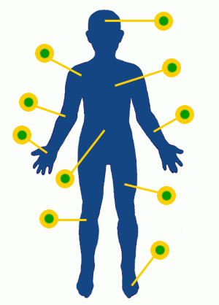

**Award Certificates**

Make sure to encourage your child every day. One way to do this is to make your own award or use the one below to reward your child for their outstanding work.

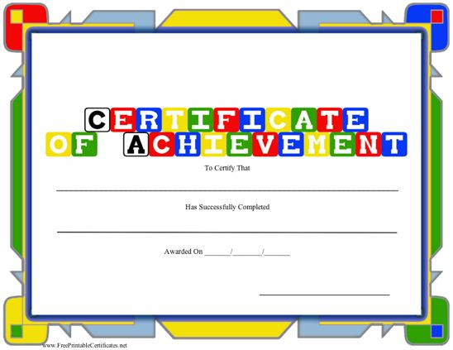

**Colors Worksheet**

Go through the colors with your child and sound out each word. Ask them what other objects are red, black, etc.?

|  |  |  |
| --- | --- | --- |
| black | blue | brown |
| black | blue | brown |
| gold | gray | green |
| gold | gray | green |
| orange | CAWTUXY9CA4ZVCLFCAFMSBVQCAWNN0Y0CA8XF249CA53ZHAICA11AZLDCA7IJSIZCAPVDS5HCA9WX7A1CAZ8G0U1CAAMIJYNCANL4RXWCA0827O0CAGHND4CCA46SZXYCALN99UWCAWY23HOCAVSN7DT.jpg | CAR36purple_l.jpg |
| orange | pink | purple |
| PH03127I%5B3%5D.jpg | white | yellow |

red white yellow

**Counting Worksheet**

Cut out each picture and show them to your child one by one. Ask them how many items there are in each picture? What color are they? What shape are they? You can do the same thing with random objects in your home.

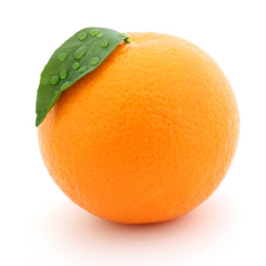 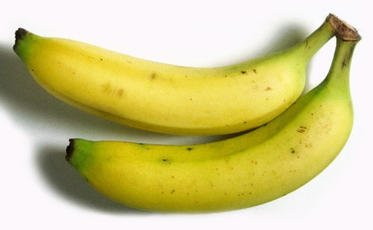 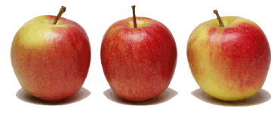 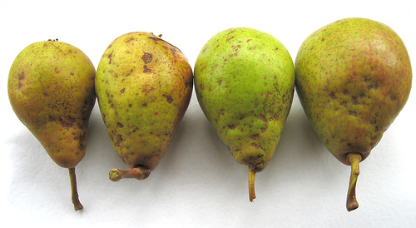 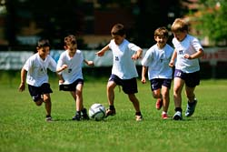 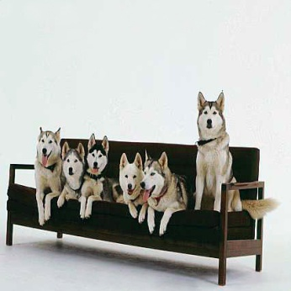 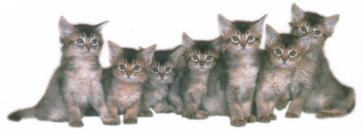 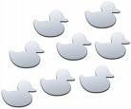 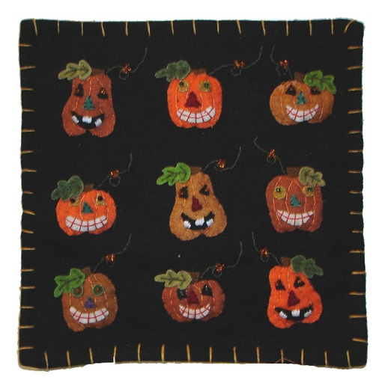 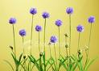

**Shapes**

Write what type of shape each picture is inside the shape. Then, color each shape a different color.

square diamond circle oval

triangle star heart rectangle